Matcont pipeline

1. Put in equations
2. Run initial point
3. Run equilibrium curve (detect hopfs)

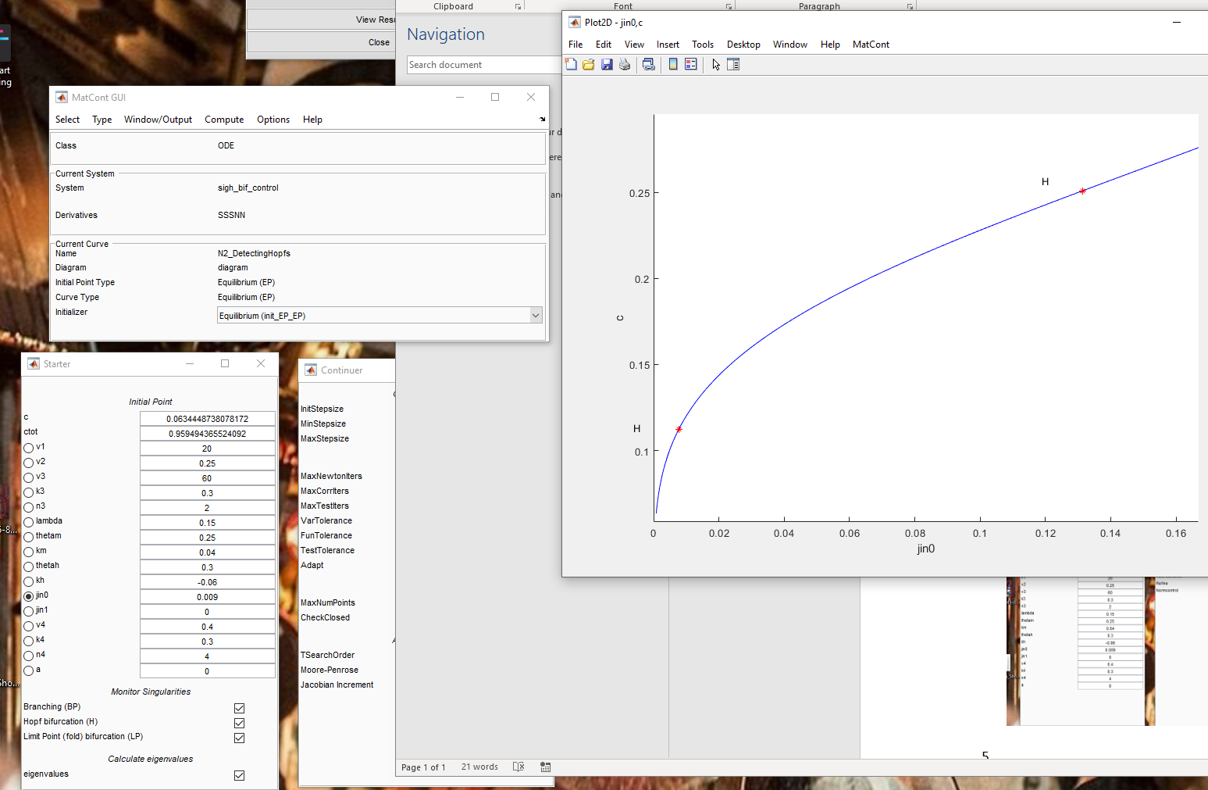

1. Start from hopf, and look for limit cycles (continuation of limit cycle)
   1. Make the step sizes correct for “period size”

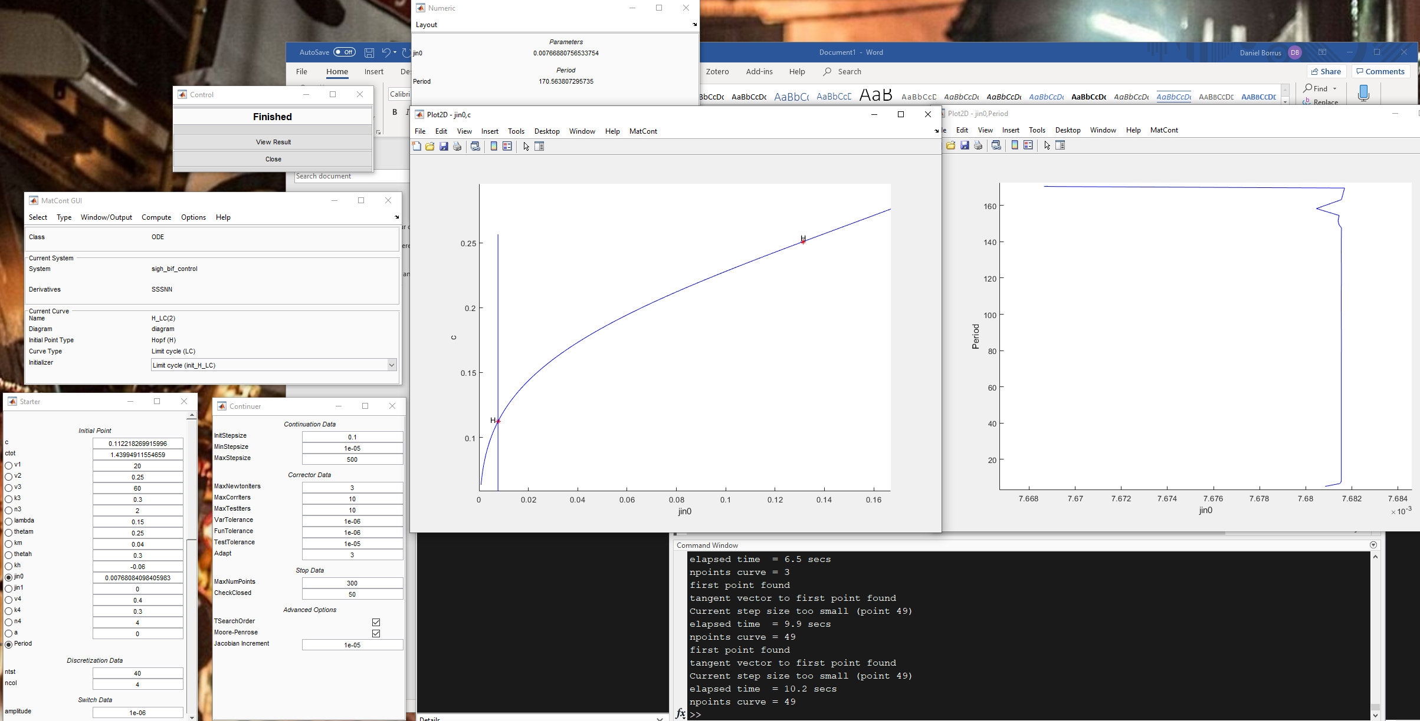

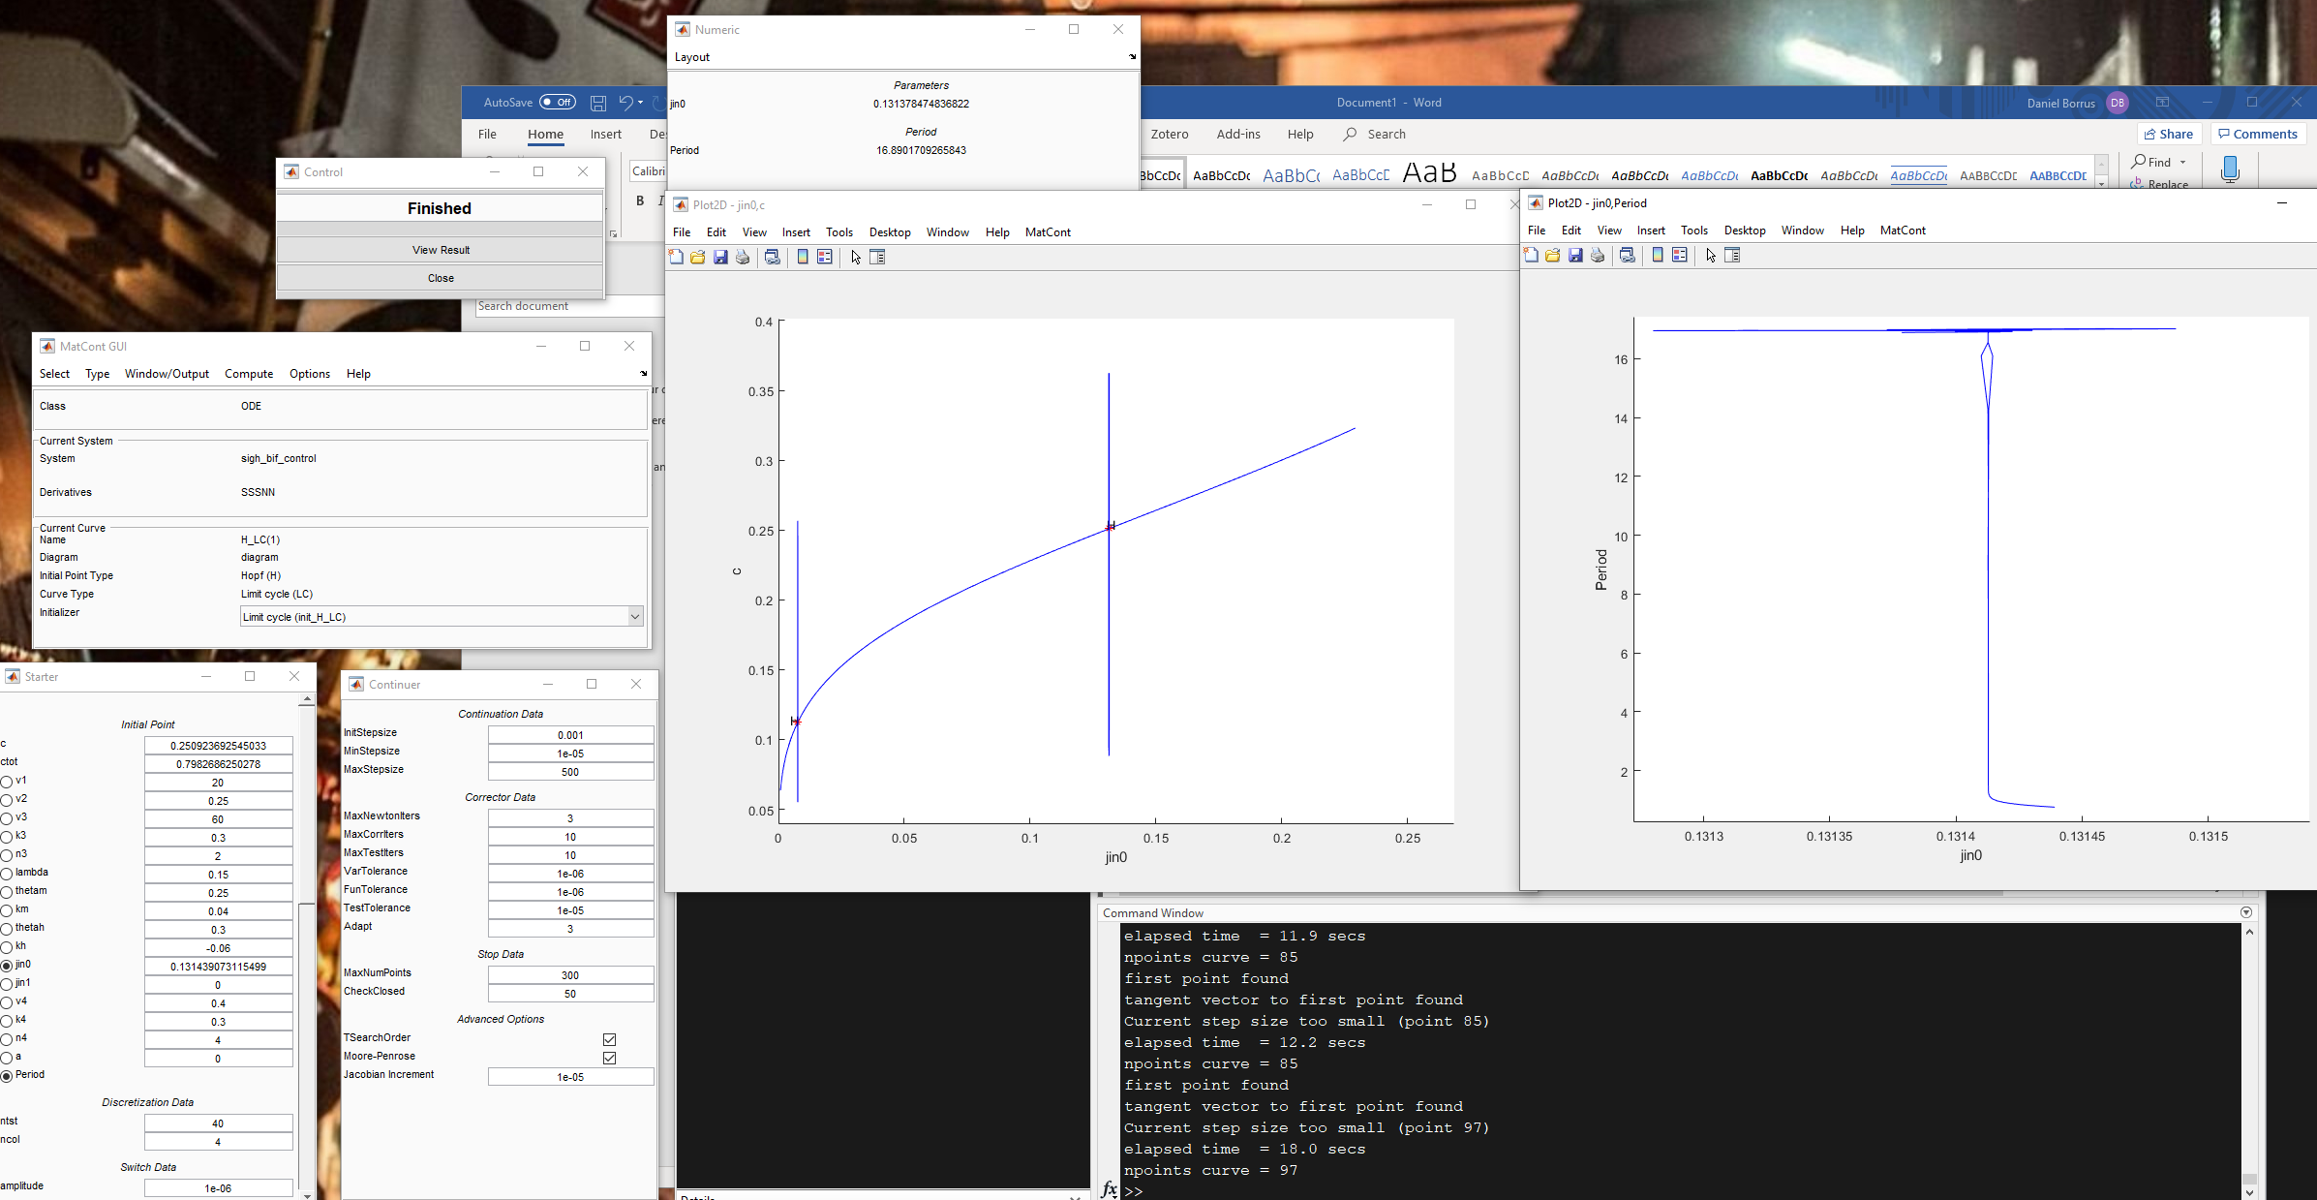

1. Get onto limit cycle

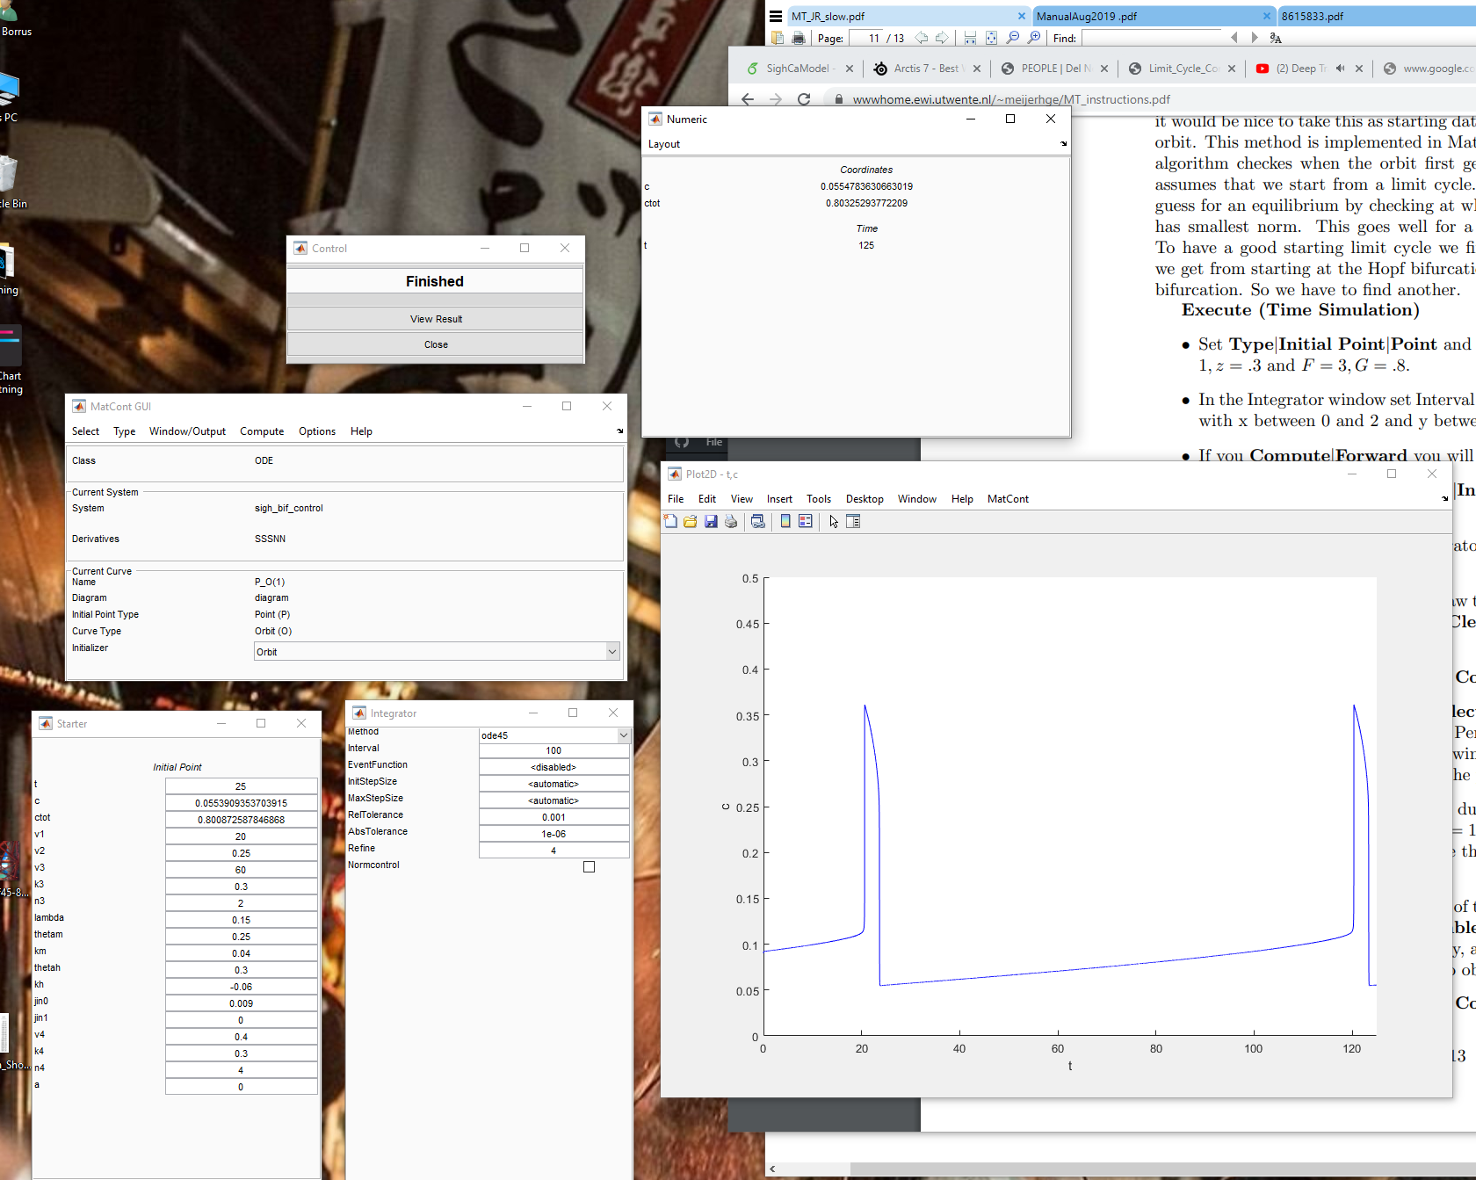

Added an eta in to slow Ca down, to make the ODEs less stiff, for the solvers.

Step 1: let loose a trajectory

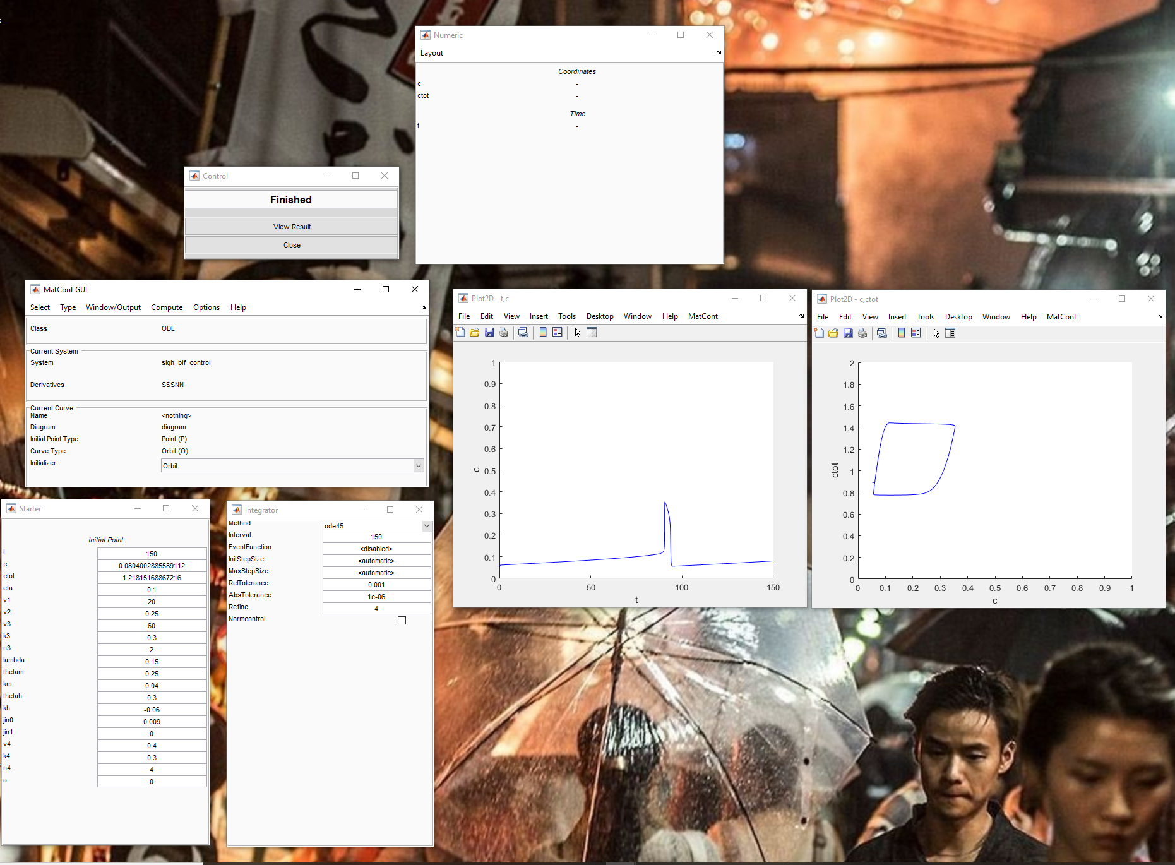

Step 2: Find equilibrium

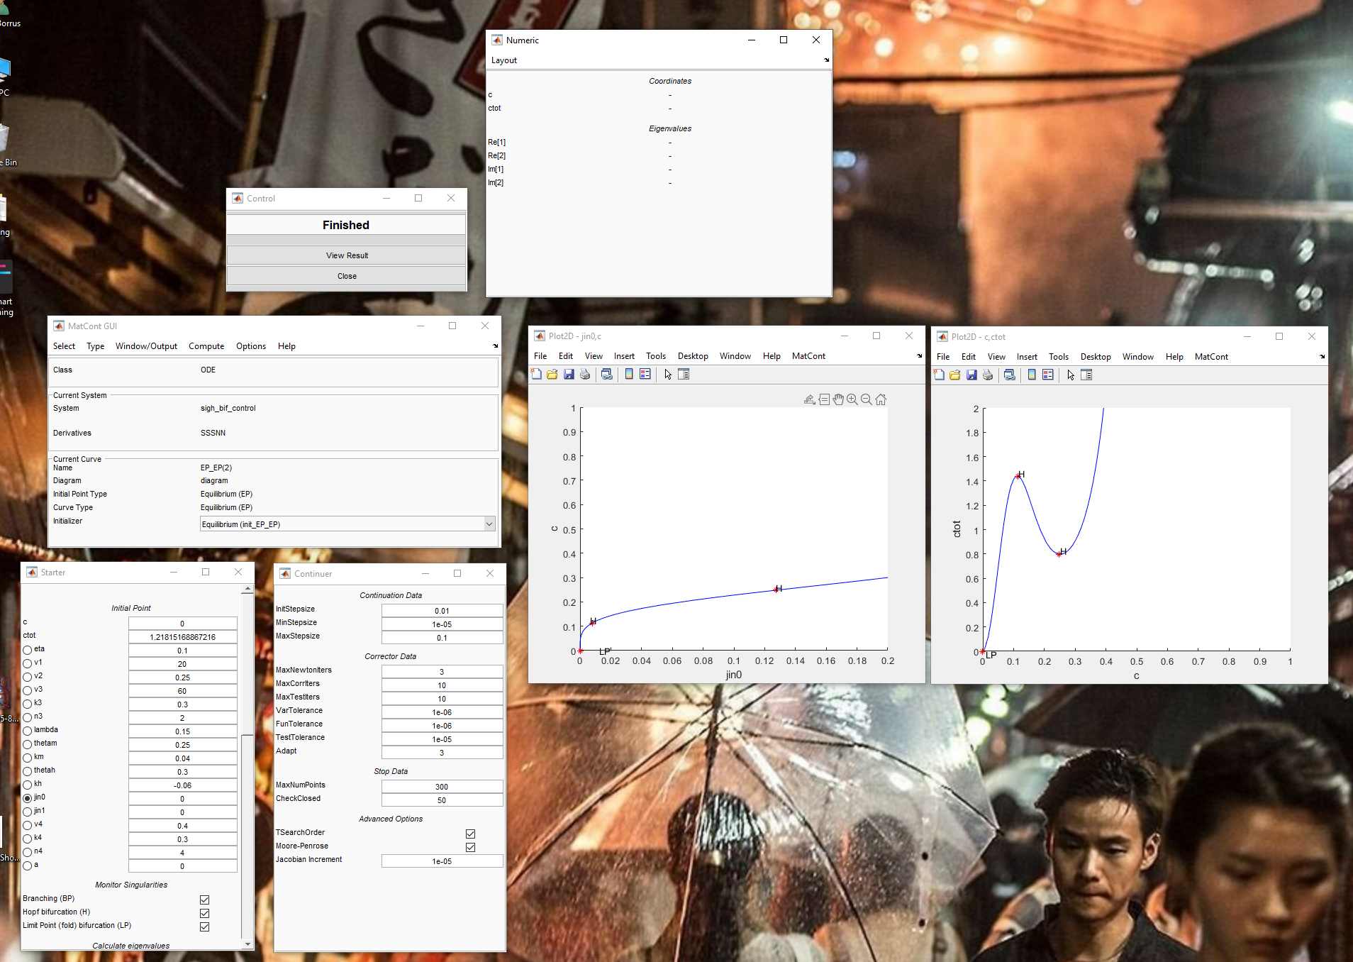

Step 3: Find Limit cycle

